Test Case: tc007_SPX_Dev5_Validacion_Boton_Edit_Administrador_Menu
Step 1 - Enter username and password and click to button Enter : Credentials Entered
Image file-name: QC_Testing-tc007_SPX_Dev5_Validacion_Boton_Edit_Administrador_Menu-nov. 21 2025, 12 02 03 p. m.

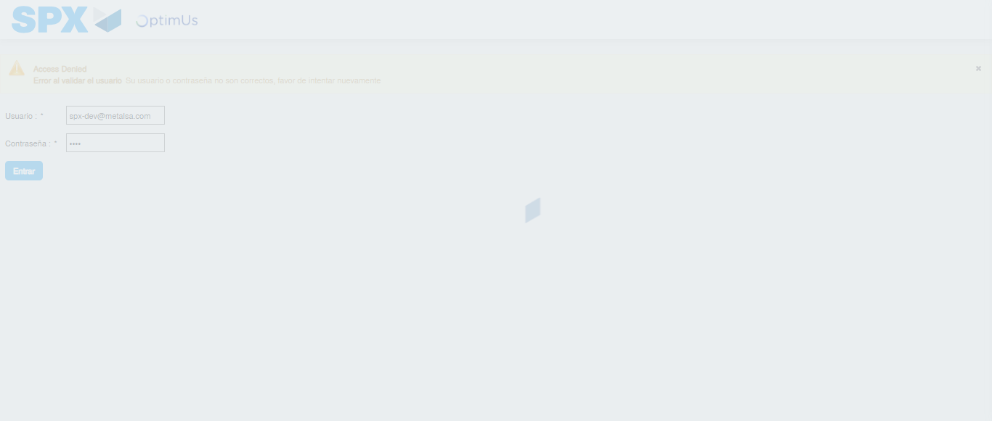Image file-name: QC_Testing-tc007_SPX_Dev5_Validacion_Boton_Edit_Administrador_Menu-nov. 21 2025, 12 02 04 p. m.

Step 2 - Select to UEN and Access to Administrador Roles Menu: UEN Correctly selected and Correct access
Image file-name: QC_Testing-tc007_SPX_Dev5_Validacion_Boton_Edit_Administrador_Menu-nov. 21 2025, 12 02 07 p. m.

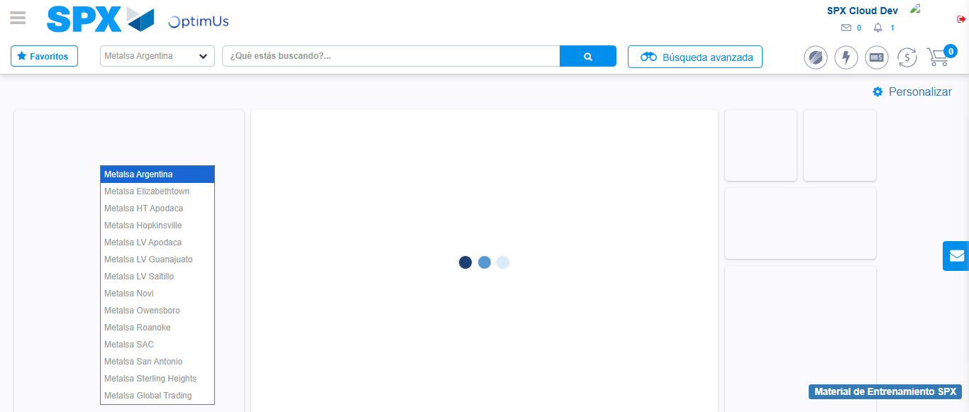Image file-name: QC_Testing-tc007_SPX_Dev5_Validacion_Boton_Edit_Administrador_Menu-nov. 21 2025, 12 02 08 p. m.

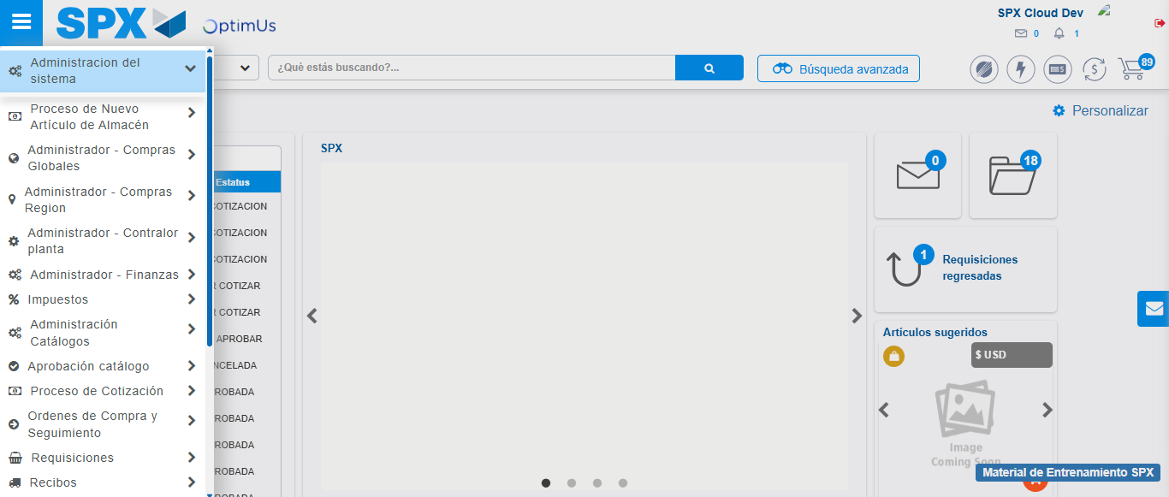Image file-name: QC_Testing-tc007_SPX_Dev5_Validacion_Boton_Edit_Administrador_Menu-nov. 21 2025, 12 02 09 p. m.

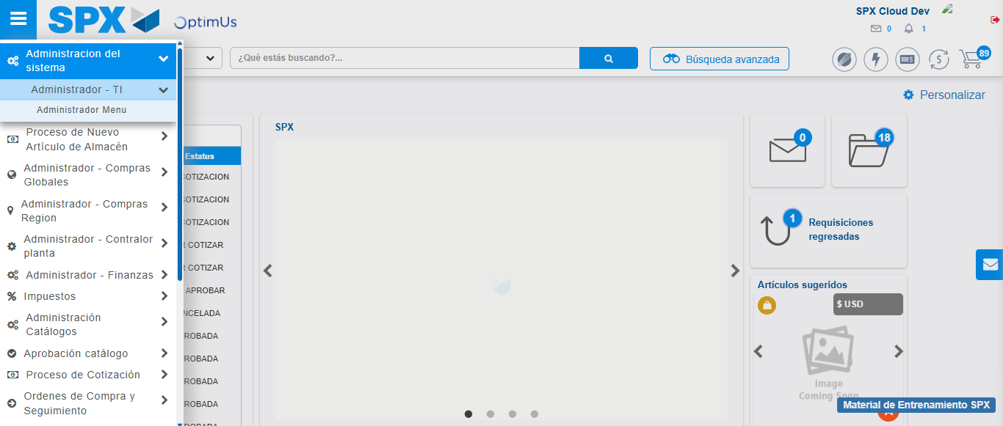Image file-name: QC_Testing-tc007_SPX_Dev5_Validacion_Boton_Edit_Administrador_Menu-nov. 21 2025, 12 02 10 p. m.

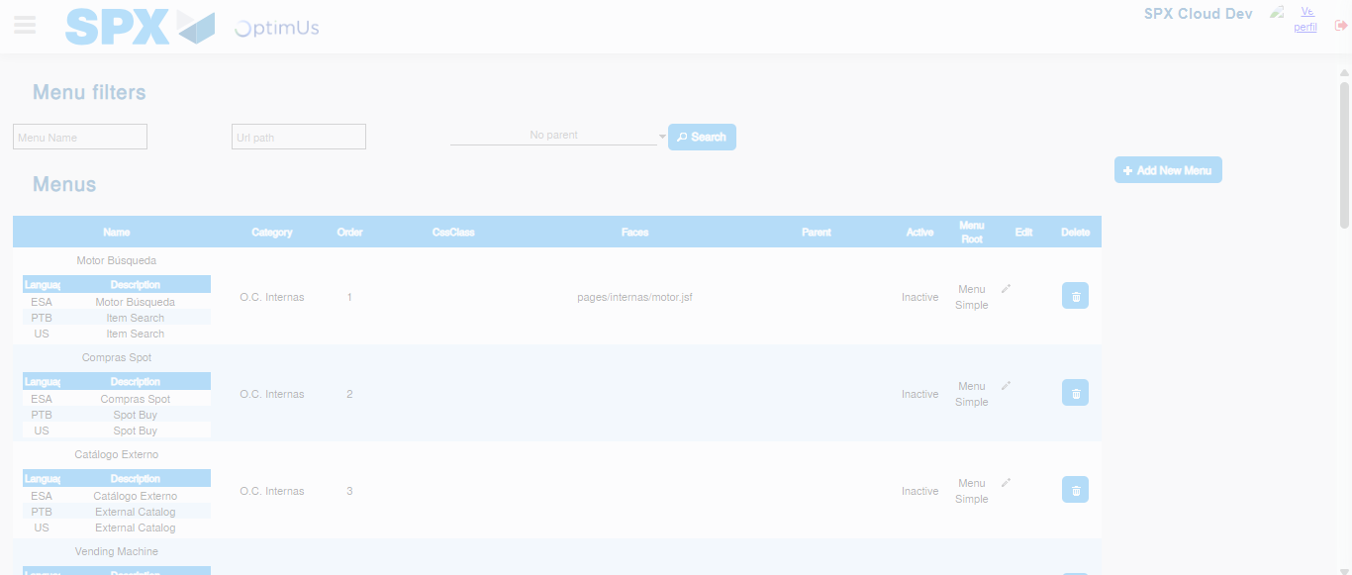Image file-name: QC_Testing-tc007_SPX_Dev5_Validacion_Boton_Edit_Administrador_Menu-nov. 21 2025, 12 02 12 p. m.

Step 3 - Add new menu and edit fields: New menu successfully registered
Image file-name: QC_Testing-tc007_SPX_Dev5_Validacion_Boton_Edit_Administrador_Menu-nov. 21 2025, 12 02 12 p. m.

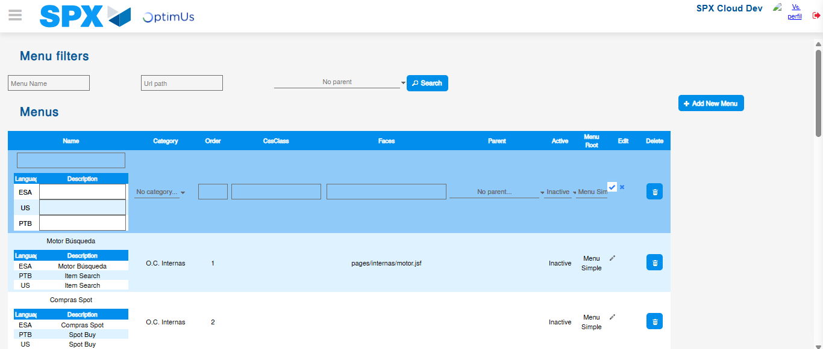Image file-name: QC_Testing-tc007_SPX_Dev5_Validacion_Boton_Edit_Administrador_Menu-nov. 21 2025, 12 02 16 p. m.

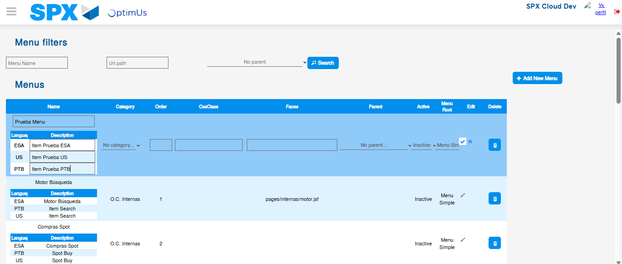Image file-name: QC_Testing-tc007_SPX_Dev5_Validacion_Boton_Edit_Administrador_Menu-nov. 21 2025, 12 02 17 p. m.

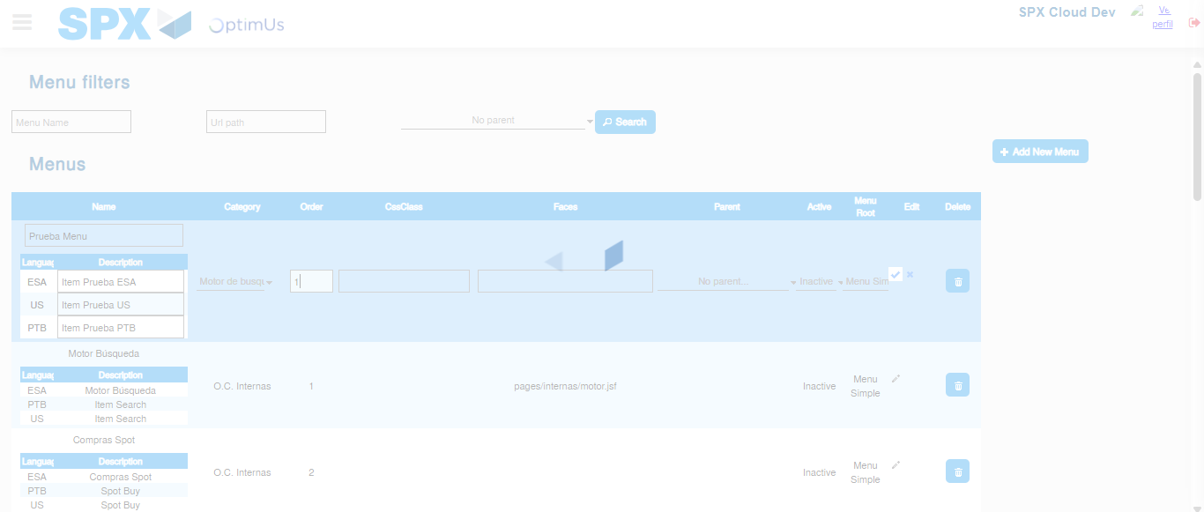Image file-name: QC_Testing-tc007_SPX_Dev5_Validacion_Boton_Edit_Administrador_Menu-nov. 21 2025, 12 02 18 p. m.

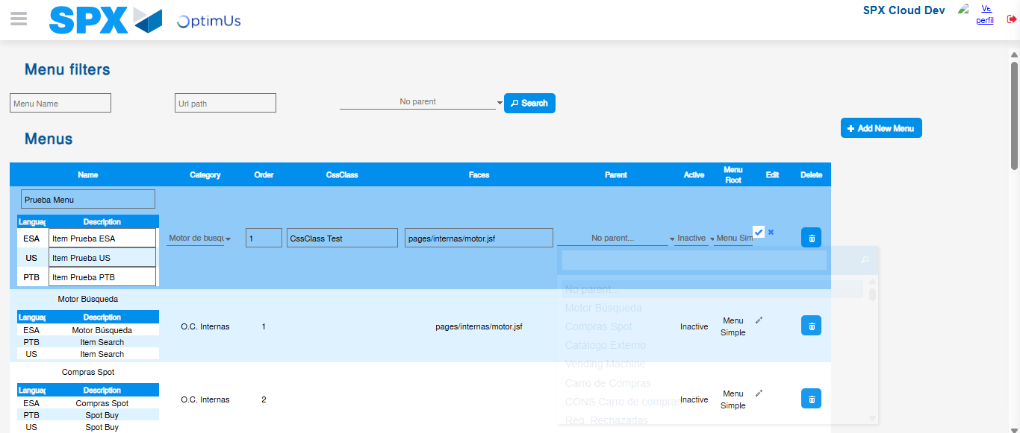Image file-name: QC_Testing-tc007_SPX_Dev5_Validacion_Boton_Edit_Administrador_Menu-nov. 21 2025, 12 02 19 p. m.

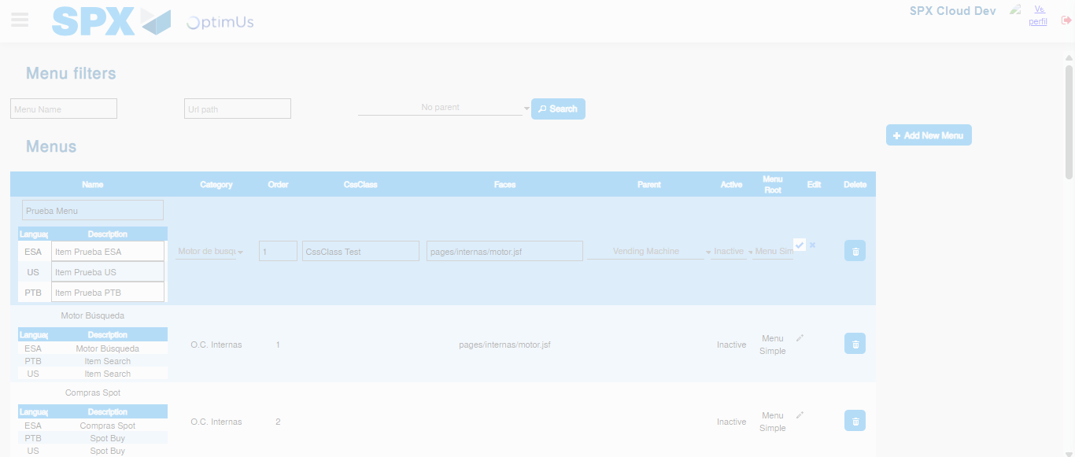Image file-name: QC_Testing-tc007_SPX_Dev5_Validacion_Boton_Edit_Administrador_Menu-nov. 21 2025, 12 02 20 p. m.

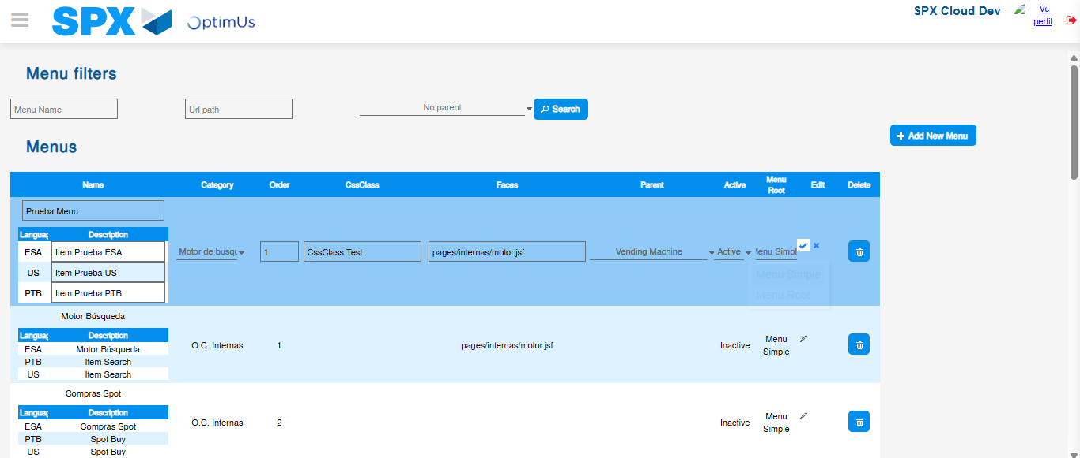Image file-name: QC_Testing-tc007_SPX_Dev5_Validacion_Boton_Edit_Administrador_Menu-nov. 21 2025, 12 02 21 p. m.

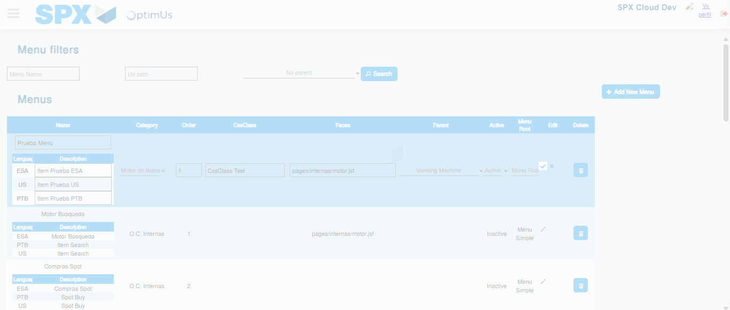Image file-name: QC_Testing-tc007_SPX_Dev5_Validacion_Boton_Edit_Administrador_Menu-nov. 21 2025, 12 02 22 p. m.

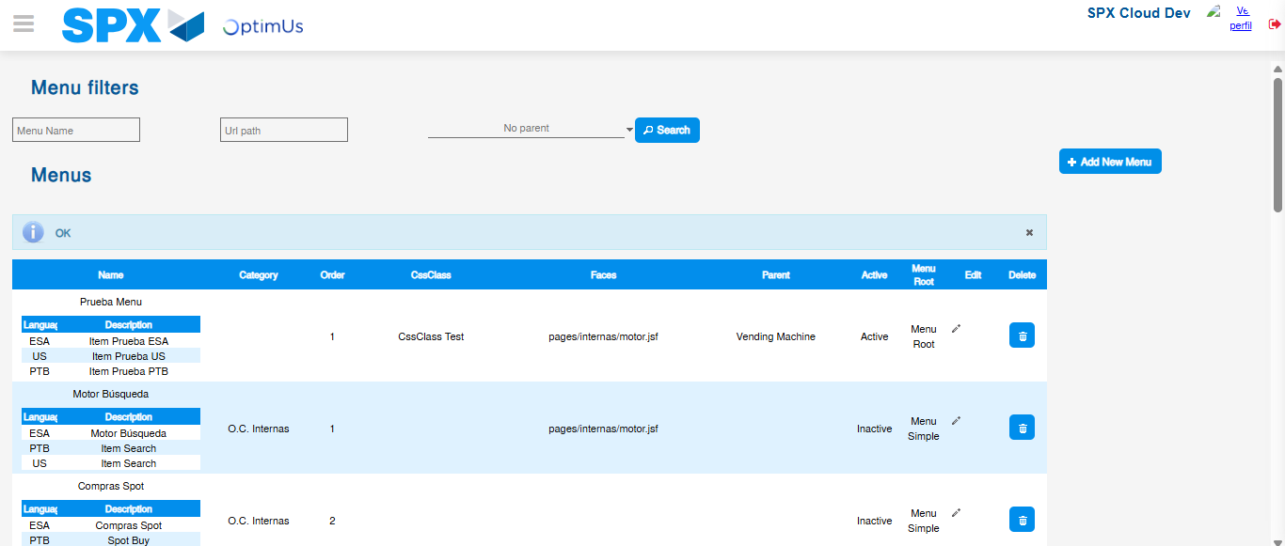Image file-name: QC_Testing-tc007_SPX_Dev5_Validacion_Boton_Edit_Administrador_Menu-nov. 21 2025, 12 02 26 p. m.

